Date: 07/10/2020

**Practical no 4**

**AIM**: Use WCF to create a basic ASP.NET Asynchronous JavaScript and XML (AJAX) service..

**Program Code:-**

**WebForm1.aspx**

|  |
| --- |
| <%@ Page Language="C#" AutoEventWireup="true" CodeBehind="WebForm1.aspx.cs" Inherits="WebApplication2.WebForm1" %>  <!DOCTYPE html>  <html xmlns="http://www.w3.org/1999/xhtml">  <head runat="server">  <title></title>  <script src="jquery.js"></script>  <script type="text/javascript">  $(document).ready(function () {  $("#btn").click(function () {  var num1 = $("#txt1").val();  var num2 = $("#txt2").val();  $.ajax({  url: "Service1.svc/Sum",  type: "POST",  contentType: "application/json; charset=utf-8",  data:JSON.stringify({a: num1, b: num2}),  dataType: "json",  success : function(data){ $("#txt3").val(data.d); },  error : function(err){  alert(err);  }  });  });  });  </script>  </head>  <body>  <form id="form1" runat="server">  <div>  <input id="txt1" type="text" />  <br />  <br />  <input id="txt2" type="text" />  <br />  <br />  <input id="btn" type="button" value="Add Number" />  <br />  <br />  <input id="txt3" type="text" />  <p> Performed by krunal 713</p>  </div>  </form>  </body>  </html> |

**Service1.svc.cs**

|  |
| --- |
| using System;  using System.Collections.Generic;  using System.Linq;  using System.Runtime.Serialization;  using System.ServiceModel;  using System.ServiceModel.Activation;  using System.ServiceModel.Web;  using System.Text;  namespace WebApplication2  {  [ServiceContract(Namespace = "Multiplication")]  [AspNetCompatibilityRequirements(RequirementsMode = AspNetCompatibilityRequirementsMode.Allowed)]  public class Service1  {  [OperationContract]  public double Sum(double a, double b)  {  double result = a + b;  return result;  }  }  } |

**Web.Config**

|  |
| --- |
| <?xml version="1.0" encoding="utf-8"?>  <!--  For more information on how to configure your ASP.NET application, please visit  https://go.microsoft.com/fwlink/?LinkId=169433  -->  <configuration>  <system.web>  <compilation debug="true" targetFramework="4.7.1"/>  <httpRuntime targetFramework="4.7.1"/>  </system.web>  <system.codedom>  <compilers>  <compiler language="c#;cs;csharp" extension=".cs"  type="Microsoft.CodeDom.Providers.DotNetCompilerPlatform.CSharpCodeProvider, Microsoft.CodeDom.Providers.DotNetCompilerPlatform, Version=2.0.0.0, Culture=neutral, PublicKeyToken=31bf3856ad364e35"  warningLevel="4" compilerOptions="/langversion:default /nowarn:1659;1699;1701"/>  <compiler language="vb;vbs;visualbasic;vbscript" extension=".vb"  type="Microsoft.CodeDom.Providers.DotNetCompilerPlatform.VBCodeProvider, Microsoft.CodeDom.Providers.DotNetCompilerPlatform, Version=2.0.0.0, Culture=neutral, PublicKeyToken=31bf3856ad364e35"  warningLevel="4" compilerOptions="/langversion:default /nowarn:41008 /define:_MYTYPE=\&quot;Web\&quot; /optionInfer+"/>  </compilers>  </system.codedom>  <system.serviceModel>  <behaviors>  <endpointBehaviors>  <behavior name="WebApplication2.Service1AspNetAjaxBehavior">  <enableWebScript />  </behavior>  </endpointBehaviors>  </behaviors>  <serviceHostingEnvironment aspNetCompatibilityEnabled="true"  multipleSiteBindingsEnabled="true" />  <services>  <service name="WebApplication2.Service1">  <endpoint address="" behaviorConfiguration="WebApplication2.Service1AspNetAjaxBehavior"  binding="webHttpBinding" contract="WebApplication2.Service1" />  </service>  </services>  </system.serviceModel>  </configuration> |

**Output:-**

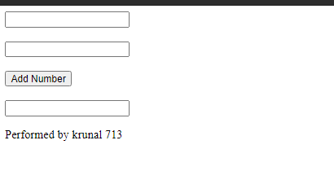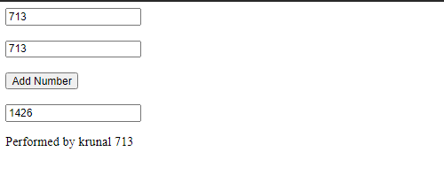

Date: 13/10/2020

**Practical no 5**

**AIM**: Implement a typical service and a typical client using WCF.

**Program Code:-**

**IService1.cs**

|  |
| --- |
| using System;  using System.Collections.Generic;  using System.Linq;  using System.Runtime.Serialization;  using System.ServiceModel;  using System.ServiceModel.Web;  using System.Text;  namespace WcfService8  {  [ServiceContract]  public interface IService1  {  [OperationContract]  int add(int a, int b);  [OperationContract]  int Sub(int a, int b);  [OperationContract]  int Mul(int a, int b);  [OperationContract]  int Div(int a, int b);  }  } |

**Service1.svc.cs:-**

|  |
| --- |
| using System;  using System.Collections.Generic;  using System.Linq;  using System.Runtime.Serialization;  using System.ServiceModel;  using System.ServiceModel.Web;  using System.Text;  namespace WcfService8  {  public class Service1 : IService1  {  int IService1.add(int a, int b)  {  return (a + b);  }  int IService1.Sub(int a, int b)  {  if (a >= b)  return (a - b);  else  return (b - a);  }  int IService1.Mul(int a, int b)  {  return (a * b);  }  int IService1.Div(int a, int b)  {  if (a >= b)  return (a / b);  else  return (b / a);  }  }  } |

**Webform1.aspx**

|  |
| --- |
| <%@ Page Language="C#" AutoEventWireup="true" CodeBehind="WebForm1.aspx.cs" Inherits="WcfService8.WebForm1" %>  <!DOCTYPE html>  <html xmlns="http://www.w3.org/1999/xhtml">  <head runat="server">  <title></title>  </head>  <body>  <form id="form1" runat="server" style="background-color:lightgray>  <div>  Enter first number  <asp:TextBox ID="TextBox1" runat="server" ></asp:TextBox> &nbsp; &nbsp;&nbsp;  Enter second number  <asp:TextBox ID="TextBox2" runat="server"></asp:TextBox> <br /><br />  <asp:Button ID="Button1" runat="server" Text="Add" OnClick="btnadd_Click" />&nbsp; &nbsp;&nbsp;  <asp:Button ID="Button2" runat="server" Text="Sub" OnClick="btnsub_Click"/>&nbsp; &nbsp;&nbsp;  <asp:Button ID="Button3" runat="server" Text="Mul" OnClick="btnmul_Click"/>&nbsp; &nbsp;&nbsp;  <asp:Button ID="Button4" runat="server" Text="Div" OnClick="btndiv_Click"/> <br /><br />  <asp:Label ID="Label2" runat="server" Text="Result:-"></asp:Label>&nbsp; &nbsp;&nbsp;  <asp:TextBox ID="TextBox3" runat="server"></asp:TextBox> <br /><br /><br /><br />  performed by krunal 713  </div>  </form>  </body>  </html> |

**WebForm.aspx.cs**

|  |
| --- |
| using System;  using System.Collections.Generic;  using System.Linq;  using System.Web;  using System.Web.UI;  using System.Web.UI.WebControls;  namespace WcfService8  {  public partial class WebForm1 : System.Web.UI.Page  {  ServiceReference1.Service1Client Client = new ServiceReference1.Service1Client();  protected void Page_Load(object sender, EventArgs e)  { }  int a, b;  protected void btnadd_Click(object sender, EventArgs e)  {  a = Convert.ToInt32(TextBox1.Text);  b = Convert.ToInt32(TextBox2.Text);  int Addition = Client.add(a, b);  TextBox3.Text = Addition.ToString();  }  protected void btnsub_Click(object sender, EventArgs e)  {  a = Convert.ToInt32(TextBox1.Text);  b = Convert.ToInt32(TextBox2.Text);  int sub = Client.Sub(a, b);  TextBox3.Text = sub.ToString();  }  protected void btnmul_Click(object sender, EventArgs e)  {  a = Convert.ToInt32(TextBox1.Text);  b = Convert.ToInt32(TextBox2.Text);  int mul = Client.Mul(a, b);  TextBox3.Text = mul.ToString();  }  protected void btndiv_Click(object sender, EventArgs e)  {  a = Convert.ToInt32(TextBox1.Text);  b = Convert.ToInt32(TextBox2.Text);  int div = Client.Div(a, b);  TextBox3.Text = div.ToString();  }  }  } |

**Output:-**

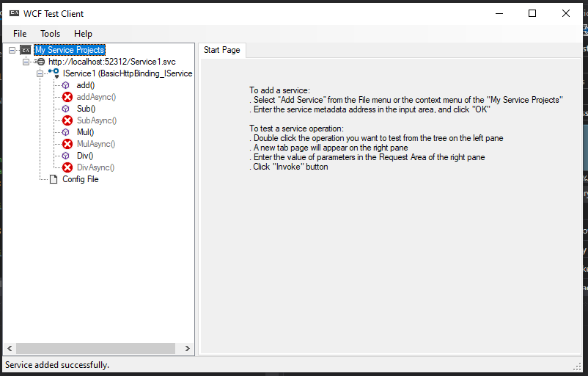

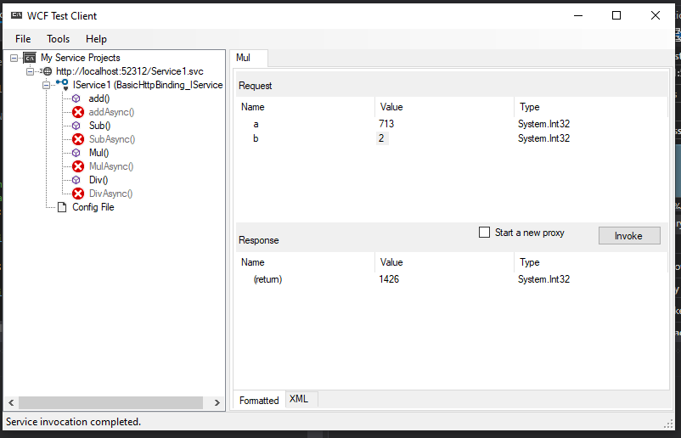

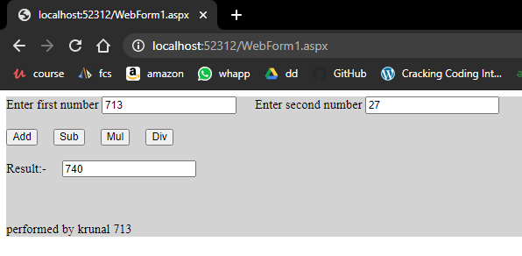

Date: 14/10/2020

**Practical no 6**

**AIM**: Develop client which consumes web services developed in different platform.

**Program Code:-**

**WebService1.asmx.cs**

|  |
| --- |
| using System;  using System.Collections.Generic;  using System.Linq;  using System.Web;  using System.Web.Services;  namespace WebApplication4  {  [WebService(Namespace = "http://tempuri.org/")]  [WebServiceBinding(ConformsTo = WsiProfiles.BasicProfile1_1)]  [System.ComponentModel.ToolboxItem(false)]  public class WebService1 : System.Web.Services.WebService  {  [WebMethod]  public double Mod(double number1 , double number2)  {  return (number1 % number2);  }  }  } |

**index.html**

|  |
| --- |
| <!DOCTYPE html>  <html>  <head>  <title>Mod </title>  <meta charset="UTF-8">  <meta name="viewport" content="width=device-width, initial-scale=1.0">  </head>  <body>  <form>  <input type="text" name="txt1" placeholder="Enter First Number"><br><br>  <input type="text" name="txt2" placeholder="Enter Second Number"><br><br>  <input type="submit" formaction="Mod.jsp" value="Mod Number"><br><br>  performed by krunal dhavle 713;  </form>  </body>  </html> |

**Mod.jsp**

|  |
| --- |
| <%@page contentType="text/html" pageEncoding="UTF-8"%>  <!DOCTYPE html>  <html>  <head>  <meta http-equiv="Content-Type" content="text/html; charset=UTF-8">  <title>JSP Page</title>  </head>  <body>  <%-- start web service invocation --%><hr/>  <%  double num1 = Double.parseDouble(request.getParameter("txt1"));  double num2 = Double.parseDouble(request.getParameter("txt2"));  try {  com.dd.WebService1 service = new com.dd.WebService1();  com.dd.WebService1Soap port = service.getWebService1Soap();  // TODO initialize WS operation arguments here  double number1 = num1;  double number2 = num2;  // TODO process result here  double result = port.mod(number1, number2);  out.println("Result = "+result);  } catch (Exception ex) {  }  %>  </body>  </html> |

**Output:-**



